As the NBN rolls out, Corryong Health’s analogue phone and fax lines are being replaced with the new digital network.
This means that the current traditional fax machines, which rely on an analogue line, will no longer be available to receive or transmit information from 11th April 2022

This has necessitated investigation into appropriate, alternate methods of transferring confidential and oversize information.

Liquidfiles has been identified as the preferred application and will be implemented by Corryong Health to transfer and receive all patient information via a LiquidFiles FileDrop.
The LiquidFiles FileDrop tool requires no registration for an external party to use.

What you need to do from 11th April 2022

Please refer to the below instructions:

To send a file to Corryong Health- these are the instructions you will give to someone who is sending documents to us
- Select the required FileDrop URL and copy it into your browser
- The FileDrop will open
- Enter your email address
- Enter the message subject
- Type the message
- Add attachments (each message can be up to 1GB in size, allowing you to send multiple attachments at once)
- Click Send
FileDrop Name | Address
Corryong Health Clinic & Administration | https://files.hrha.org.au/filedrop/CHClinicAdministration
Corryong Health Executive | https://files.hrha.org.au/filedrop/CHExecutive
Corryong Health Acute & Residential | https://files.hrha.org.au/filedrop/CHAcuteResidential
Corryong Health Allied Health | https://files.hrha.org.au/filedrop/CHAlliedHealth

Setting up Two-Factor Multi authenticator
You will need to do this to be able to access documents
- On your mobile phone you will need to download an authentication app- such as Duo Mobile, Google Authenticator and Microsoft Authenticator
- On your computer screen you will have a QR code- scan this QR code
- You will then get a passcode that you can use to enter onto your computer to open up documents

Opening up documents received from other organisations
Documents will go into what is called a FileDrop mailbox. Corryong Health has four of these set up:
- CH Acute & Residential
- CH Clinic & Administration
- CH Executive
- CH Allied Health
Only staff who require access to documents in these areas will have access to these mailboxes.

- You will receive an email into your inbox like you normally would for other emails
- Click on the link of the document
- You will then get a message like the following:
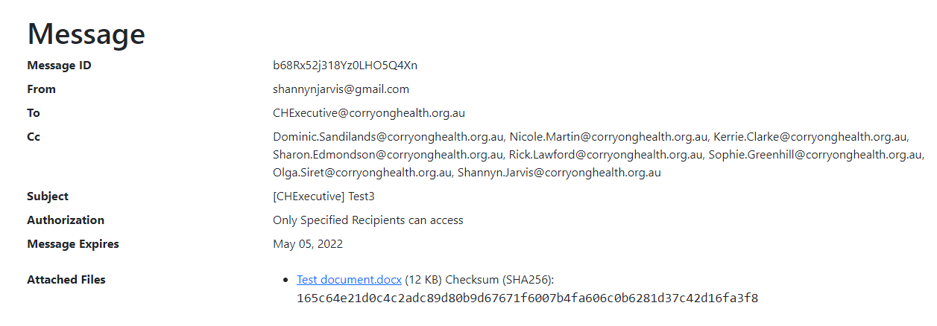

Click on the attached files link to get open the document

Receiving a file from Corryong Health- these can be given to organisations you are sending documents too

Two emails will be sent to the recipient to complete the download process

- The first email will contain a URL link to download the attached files
- Click on the link and enter your email address
- A second email will contain a “Secure Token” passcode to open the file. (The passcode is valid for 15 minutes and will then expire. If the passcode expires, a second one will need to be requested when prompted)
- Copy and paste the passcode into the required field to complete the verification process
- The attached files will be available to download the verification process
- The attached files will be available to download within 14 days of receipt. If the file is not opened within 14 days, it will need to be re-sent
- Once the verification process has been completed and the file/s accessed, an email will be sent to the sender confirming the file/s have been downloaded
If you do not receive an email containing the passcode, please check your spam folder in the first instance

